

Data Technician

Name: Lisa Weipert
Course Date: 17th to 21st November 2025
Table of contents
Day 1: Task 1 3
Day 2: Task 1 4
Day 2: Task 2 6
Day 2: Task 3 8
Day 3: Task 1 11
Day 3: Task 2 14
Dataset: 14
Step 1: Create a Pivot Table 14
Step 2: Use the SWITCH Function 14
Submission: 15
Day 3: Task 3 16
Day 4: Task 1 17
Course Notes 19
Additional Information 20

Day 1: Task 1

Please complete the below boxes on commons laws and regulations that must be followed when working with customers data, use the below bulleted list to support your answers.

- What is it
- Why is it important
- Provide a real-world example of how you can follow it
- How does it impact working with data
- What could happen if you breached it

Data Protection Act | A UK law that works alongside the UK GDPR and details how personal data must be handled. It gives individuals rights over their personal information and ensures organisation follow clear standards. The act requires keeping customer records secure, accurate and up to date. It also limits how long data can be held. A failure to keep data secure can lead to Information Commissioner’s office (ICO) investigations/audits, fines, legal claims from affected individuals and damage to company reputation.
GDPR | UK GDPR is the main data protection law and requires organisations to follow strict rules when handling personal data. This includes data minimisation, accuracy, storage limitation and security. It gives people rights such as accessing their data, having it corrected or erased, restricting processing and objecting to automated decisions. It is based on the EU GDPR but now stands as a separate UK law. Internal/external communications should not include unnecessary personal information of customers. Customers must be informed of how their data will be used and can request evidence from an organisation. If there is a breach companies can be subject to fines, legal action and loss of customer trust. Individuals may be subject to disciplinary action.
Freedom of Information Act | A law that gives the public the right to access information held by public authorities. It promotes transparency, accountability and trust in public services. Some information may be withheld such as personal or commercially sensitive data. Public sector workers must know what information can be released and what must be protected. It is a criminal offence to destroy, hide, alter or block access to information.
Computer Misuse Act | The act aims to secure computer systems against unauthorised access and modifications, ensuring the integrity and confidentiality of computer data. For example hacking, malware, deleting data without permission. It is a legal framework to combat cybercrime and help keep digital systems secure. It is important to keep login details secure, not use others login details and only accessing systems you have been given authorisation to. Follow security protocols, use strong passwords and be aware of scams where you can inadvertently give access to others. If breached this could lead to criminal charges, fines and dismissal from employment.

Day 2: Task 1

Please research and complete the following tasks within the retail-sales_dataset.xlsx document, paste a print screen into the provided boxes below:

- In the sheet ‘retail_sales_dataset’ add all available data between columns A –J into a ‘table’
- Using the ‘sort’ function, sort ‘Age’ to ‘largest to smallest’
- Using the ‘SUM’ function, show me the commission total in cell ‘L10’
- Using the ‘AVERAGE’ function, show me the average commission in cell ‘L11’

Print screen 1 | 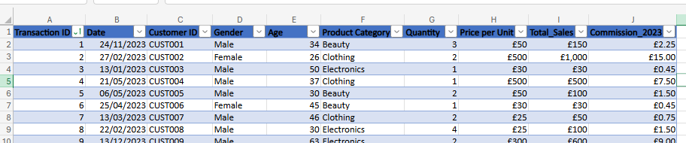
Print screen 2 | 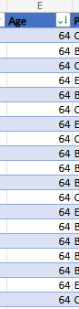
Print screen 3 | 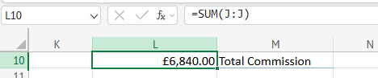
Print screen 4 | 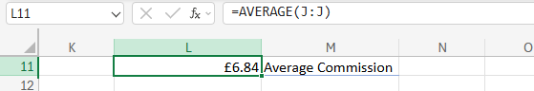

Day 2: Task 2

Please research and complete the following tasks within the retail-sales_dataset.xlsx document, paste print screens into the provided box below:



Print screen 1 | Task 1  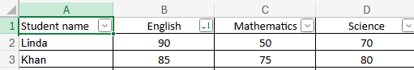  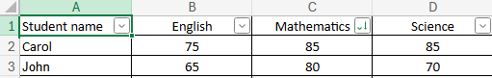  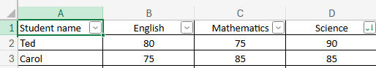  Task 2,3 & 4  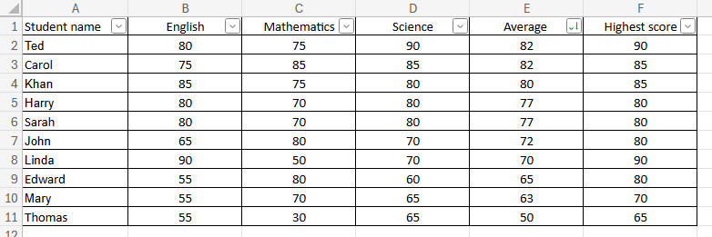  Task 5  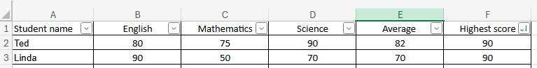  Task 6  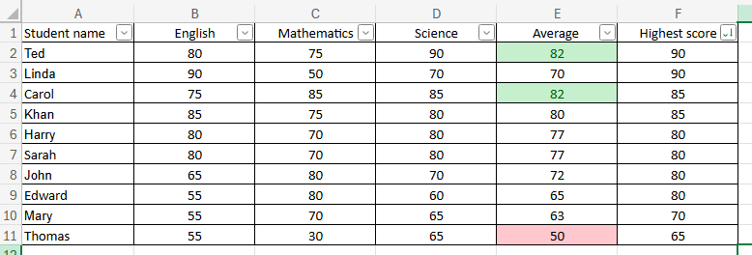

Day 2: Task 3

Using the skills developed today, have some fun with the data set you have imported. Paste your work below and enjoy!

Print screen 1 | 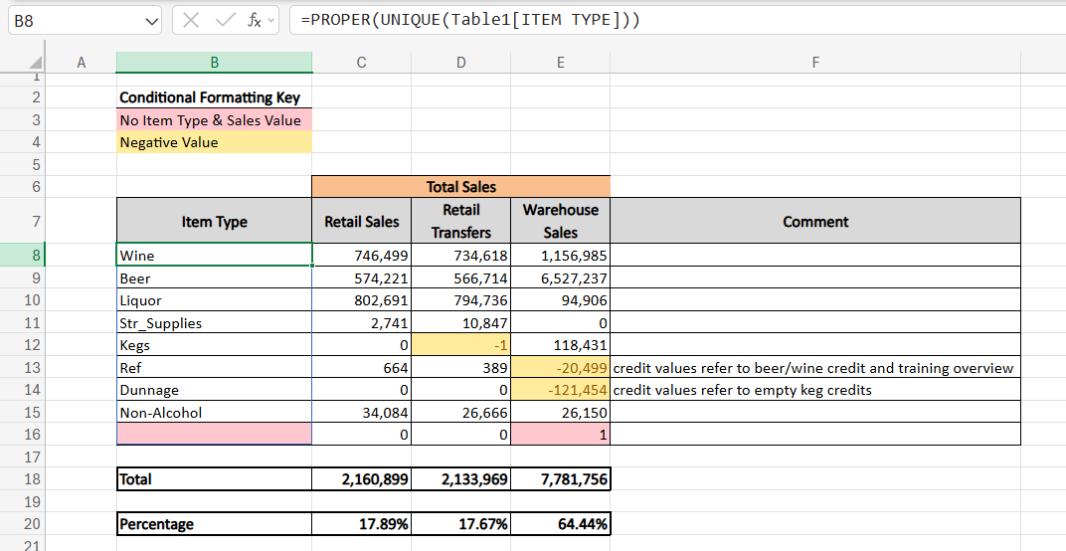  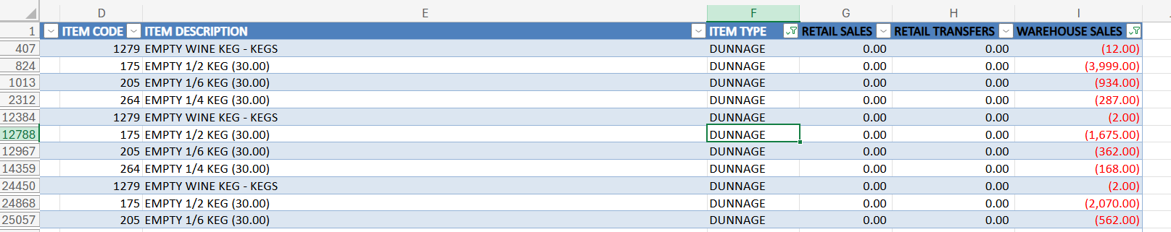  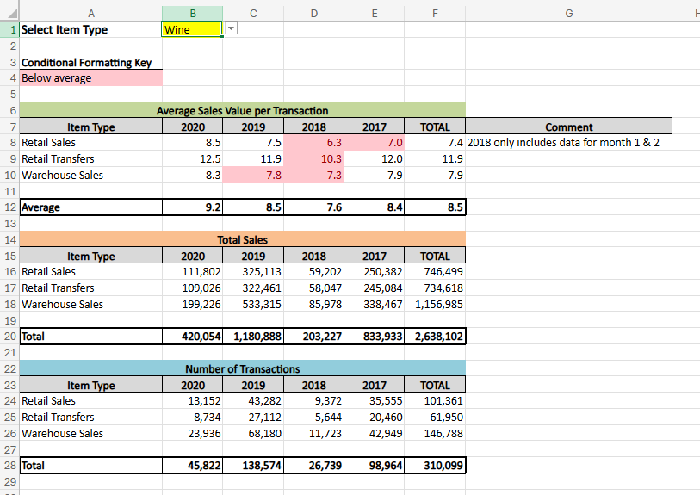  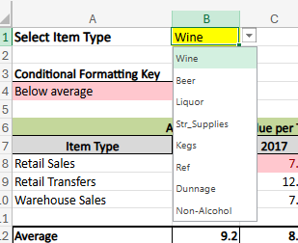  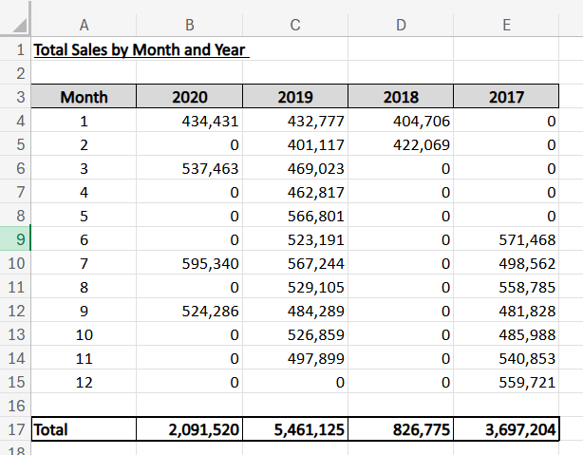  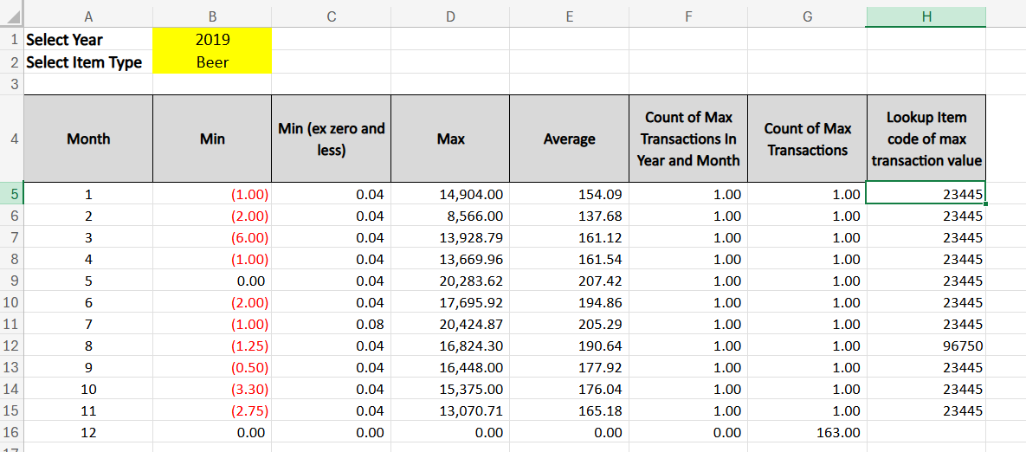  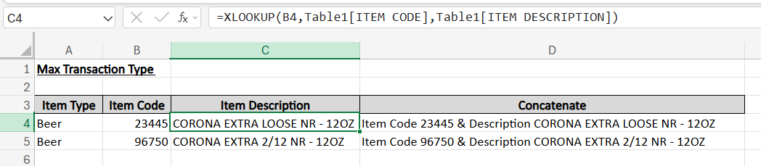

Day 3: Task 1

Please download the dataset ‘Day_3_Task_1_Bike_Sales_Pivot_Lab.xlsx’ and the lab instructions.

Do not worry if you do not complete the lab, just working with data and playing with the pivot table will be good experience.

Please paste your final pivot table below and complete the reflection questions:

Print screen 1 | 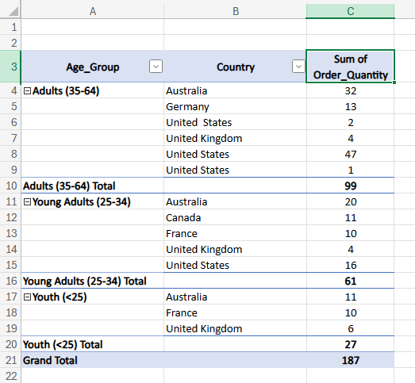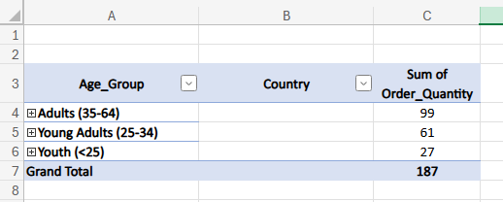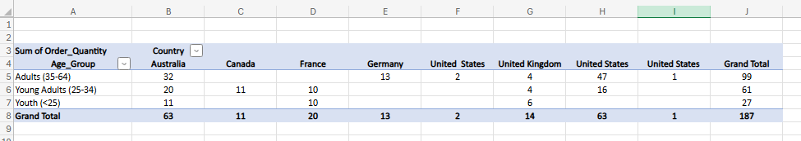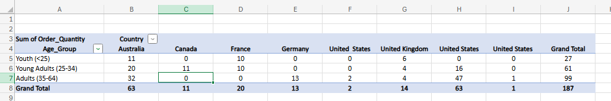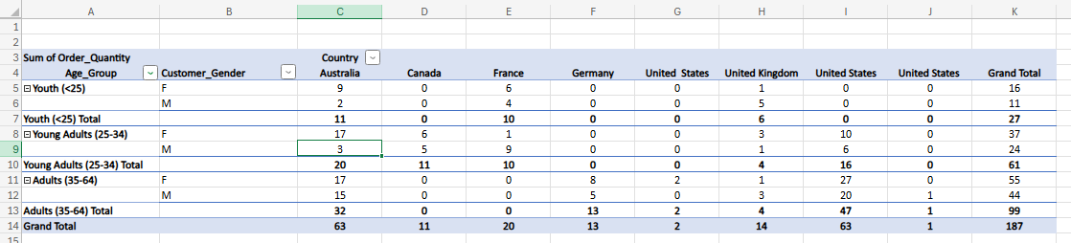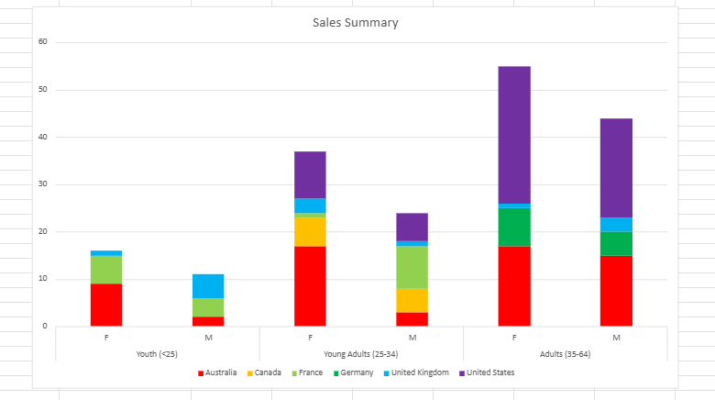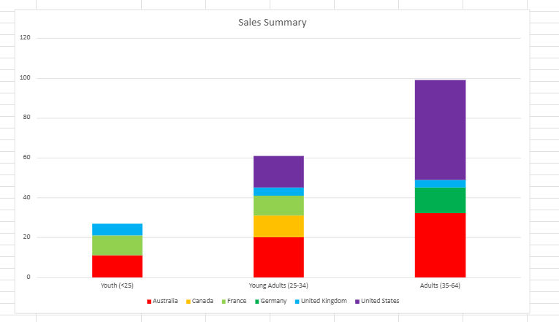
In which markets does Germany have customers? | Adults (35-65)
What country has sales in all markets? | Australia and United Kingdom
What are the most profitable markets by country, age group, and gender? | All together - Adults (35-64), Females, United States  Country – United States  Age Group – Adults (35-64)  Gender - Female
Any other findings? | There were three different formats of united states which I noticed and corrected when producing the graph.  A large portion of sales in France are to Young Adult Males. I’ve noted this because it makes up 45% of sales in France and Females purchase more than males overall. This seems unique to the French market.

Day 3: Task 2

The dataset below tracks the sales performance of different products in various counties in England. Please paste the dataset into a blank Excel workbook. Your task is to:
- Create a Pivot Table to summarise the data by county and product.
- Use the SWITCH function to categorise products based on their sales volume.

Dataset:
County | Product | Sales Volume
Yorkshire | Laptops | 500
Yorkshire | Smartphones | 200
Cornwall | Laptops | 700
Cornwall | Printers | 400
Lancashire | Smartphones | 150
Lancashire | Laptops | 600
Essex | Printers | 800
Essex | Smartphones | 300
Durham | Laptops | 250
Durham | Printers | 300
Greater Manchester | Smartphones | 600
Greater Manchester | Laptops | 400

Step 1: Create a Pivot Table
- Select the dataset (columns A to C).
- Insert a Pivot Table to summarise the data by County in the rows and Products in the columns. Use Sales Volume as the value to be summarised.

Step 2: Use the SWITCH Function
In a new column next to your data, use the SWITCH function to categorise products based on Sales Volume as follows:
  - For sales greater than 600: "High"
  - For sales between 300 and 600: "Medium"
  - For sales less than 300: "Low"
SWITCH Function Example:
=SWITCH(TRUE, C2 > 600, "High", C2 >= 300, "Medium", "Low")
- Apply this formula to each row, and check if the products are categorised correctly.

Submission:
- A completed Pivot Table summarising sales by county and product.
- A new column in the dataset categorising products by sales volume using the SWITCH function.
  - Please paste your completed work below

Print screen 1 | 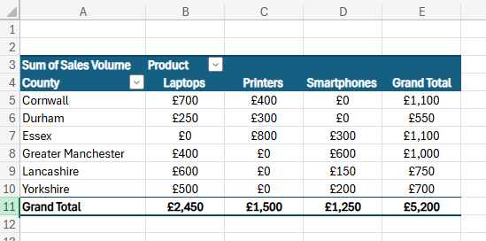  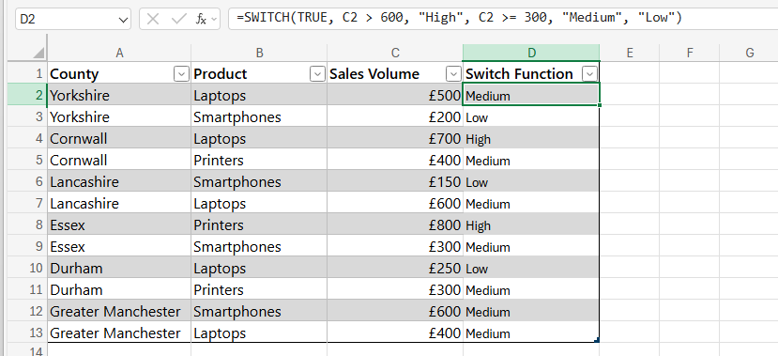

Day 3: Task 3

Please download the dataset ‘Day_3_Task_3_Bike_Sales_Visualisations_Lab.xlsx’ and the the lab instructions. Do not worry if you do not complete the lab, just working with data and playing with the charts will be good experience.

Please paste your results below:

Print screen 1 | 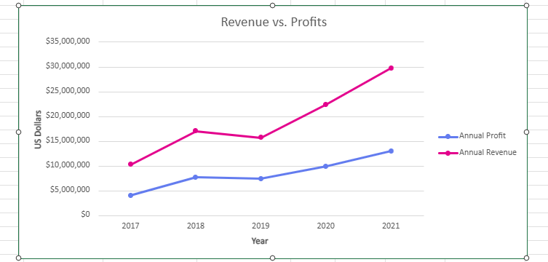  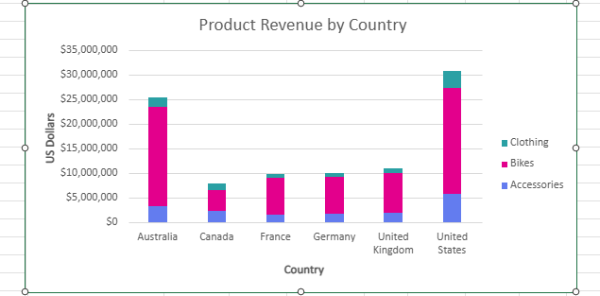  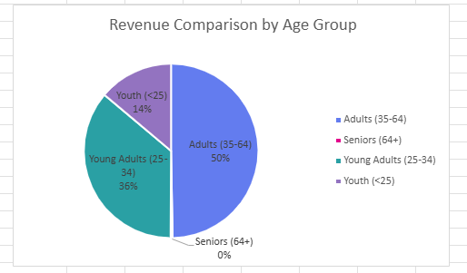

Day 4: Task 1

You have been asked to deliver your analysis findings to the board of directors, with your analysis you have identified that customers are leaving your company at the 12-month point, this is typically when they receive their renewal price.

Conduct research and complete the below questions:

How would you prepare for the delivery? | Understand who will be in the meeting and their priorities. Review datasets and make sure the numbers are accurate. Make note of any limitations to the data and prepare answers to predictable questions.  Have a clear message that is easy to follow with recommendations.  Rehearse
What tools would you use for the delivery? | Presentation  Providing supporting information before the meeting  Key cards for reference
What is prospecting and why would you complete this before your delivery? | Prospecting is gathering intelligence ahead of time i.e. understanding the needs, expectations and decision making preferences of the audience.  To make sure the message is delivered in a way that is meaningful and impactful.
Tell me best practices for public speaking and providing updates to senior leaders | Being concise and keep visuals simple.  Don’t rush and be engaged with the audience by having eye contact.  Speak loudly to make sure the whole audience can hear which also makes you sound more confident.  Don’t fidget or pace as this can distract from what is being said.  Keep the narrative clear and recommendations succinct.  Leave time for questions.
What will you show the board in your delivery? | Slide 1 – Brief description of the problem and impact. Plus the recommendation headlines.  Slide 2 – Evidence of the problem such as a line chart.  Slide 3 – Analysis of root cause such as summary of KPI’s i.e. complaints and customer feedback themes or competitor pricing comparison  Slide 4 – Financial impact  Slide 5 – Recommendations  Slide 6 – Expected outcomes and KPI’s to measure success  Slide 7 – Potential risks and mitigations
How will you articulate the changes that are needed? | The aim is to have a structured conversation with your audience. Delivering a clear story that ends with a conclusion that provides clarity to the audience and keeps the focus on what matters.
Provide a list of online resources and videos that will support your preparation for public speaking | Data_Day4 - PPT  Youtube channels e.g. Alexander Lyon  Ted Talks  LinkedIn Learning  ChatGPT
Evaluate tools that provide visualisation.  Tell me what they are.  Tell me what you would choose when delivering your presentation and why | Excel provides ability to create charts and pivot tables which are simple and widely used. Although the details in an excel workbook will likely be too detailed to use in a presentation.  PowerPoint makes it easy to present information in a consistent format for board meetings. However, the visuals, like charts, usually come from other sources, such as Excel.  Power BI & Tableau can be used to generate visuals but I’m more familiar with excel.

Course Notes

It is recommended to take notes from the course, use the space below to do so, or use the revision guide shared with the class:

Additional Information

We have included a range of additional links to further resources and information that you may find useful, these can be found within your revision guide.

END OF WORKBOOK

Please check through your work thoroughly before submitting and update the table of contents if required.

Please send your completed work booklet to your trainer.

